**BASH SCRIPTING**

1. Create on Bash script to check if a directory is available or not.

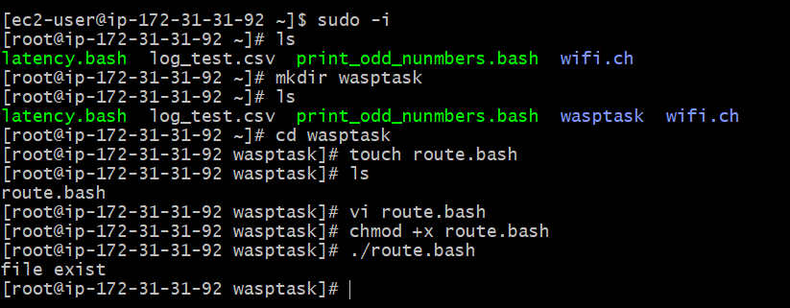

1. Create a bash script which will create multiple files.

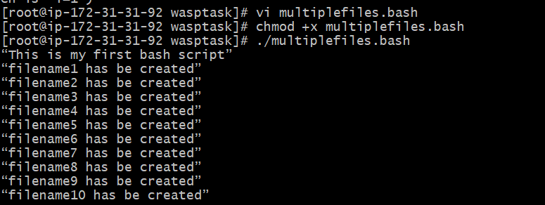

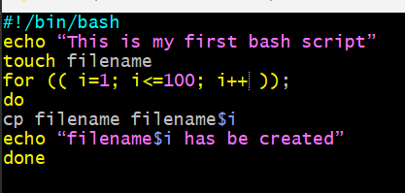

3) Create a bash script to take backup of a directory.

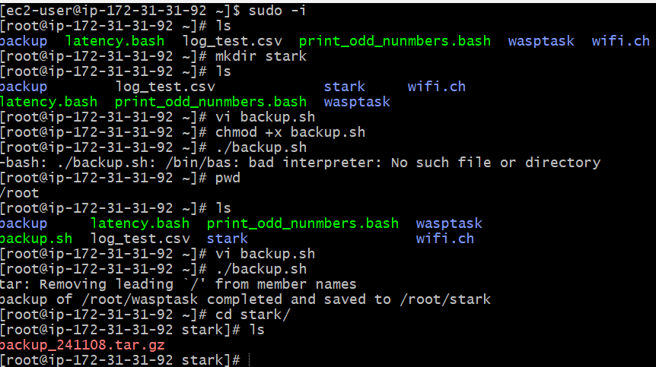

4.Create a bash script to install nginx in ec2 server.

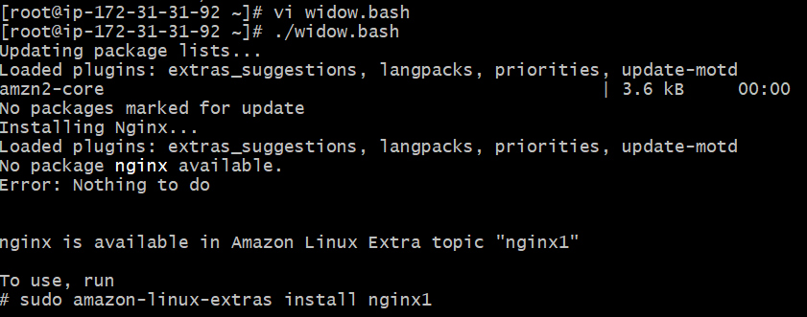

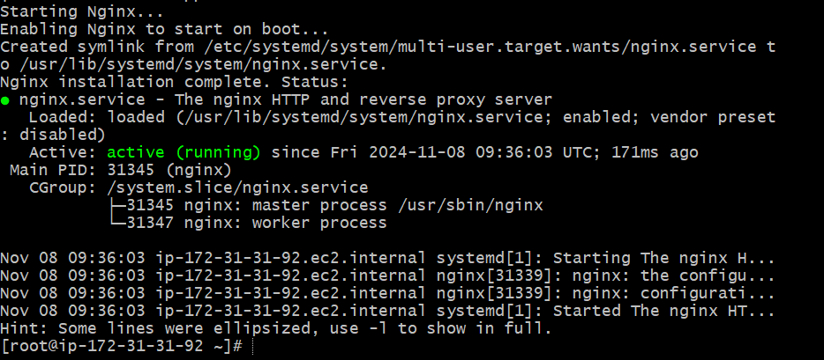

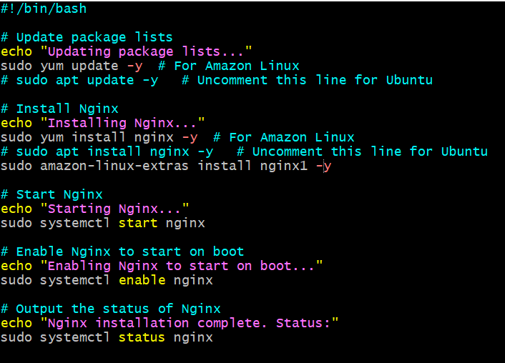

5Create a bash script to install ApacheTomcat in ec2 server.

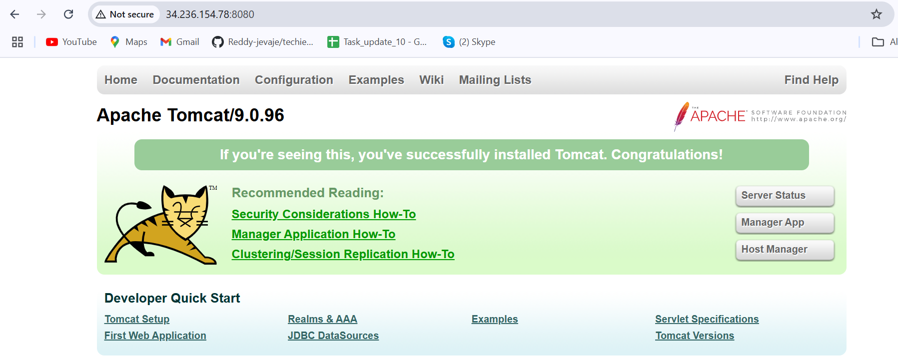

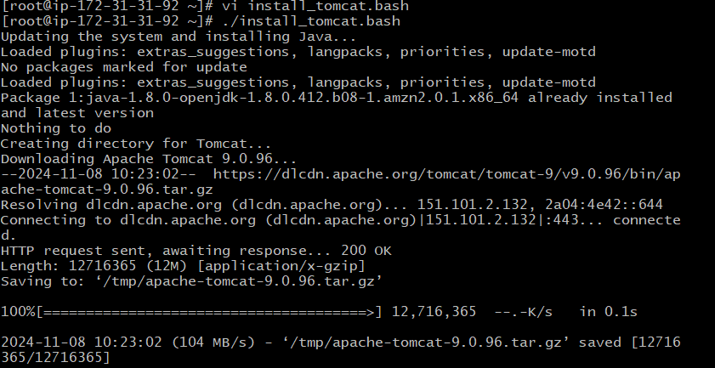

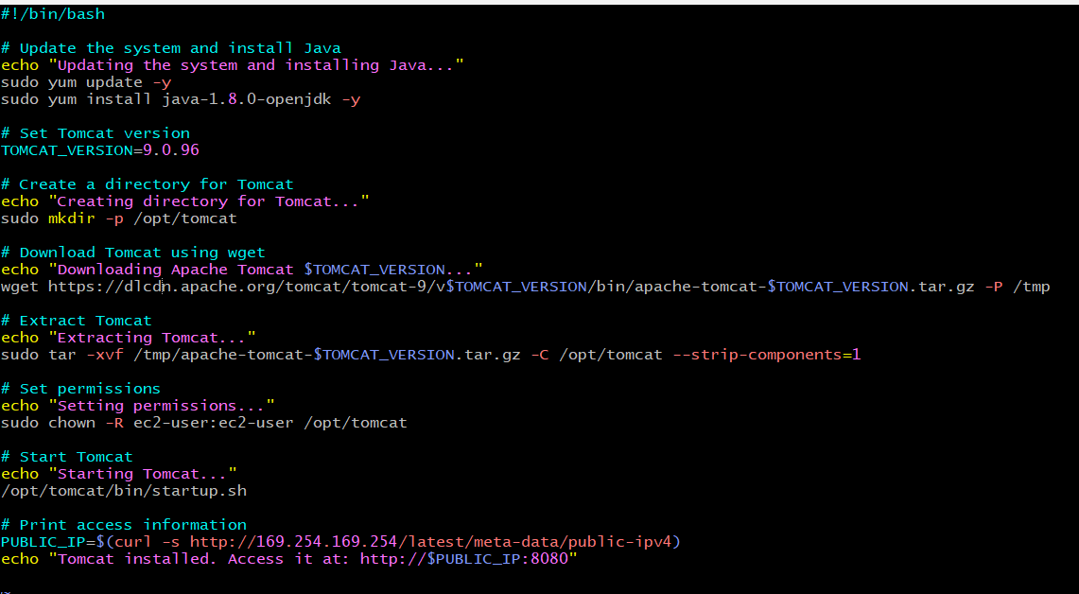

6 Create a bash script to check list if nginx service is running or not,if not running then script should start the service.

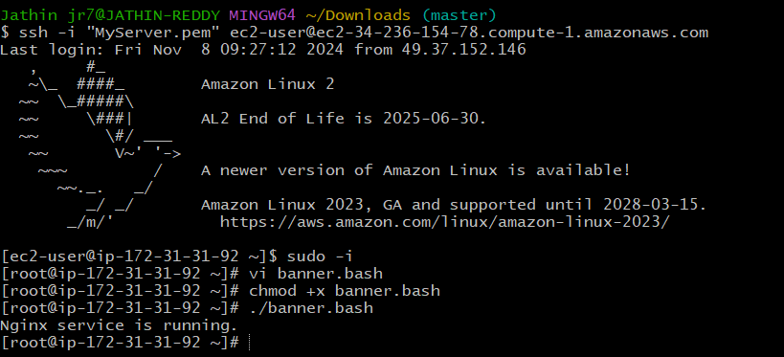

7) Create a bash script for calculator.

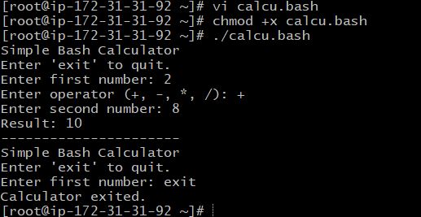

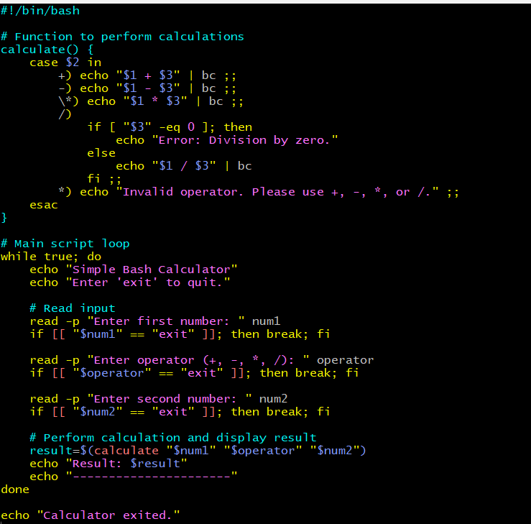

8) Create a bash script to check if directory is avaialble or not,if not then create a directory.

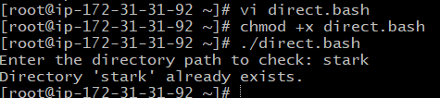

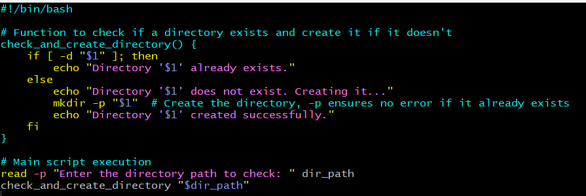

9) Create bash script to delete last 3 lines for a file.

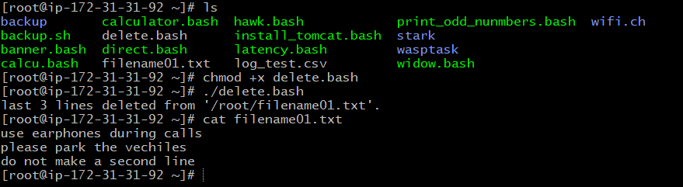

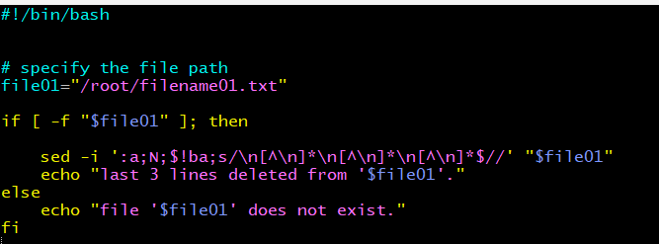

Exercise Crontab Entries :

1. April 5th Midnight

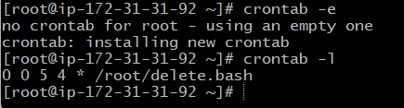

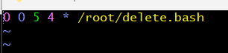

1. 5 th of Every November,Jan,June if it is a Thursday.

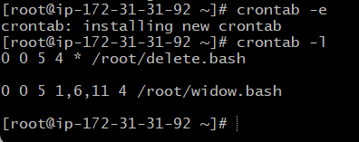



1. At 05 and 27th minutes of 9,10,11 hours everyday.

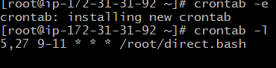



1. 34 min. of 9th hour on 15th Aug.

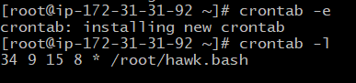

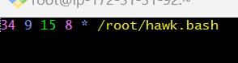

1. Every midnight

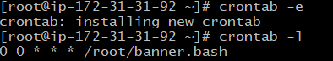



1. Every Weekend ( Saturday night 11.59 )

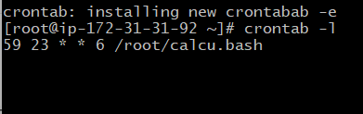

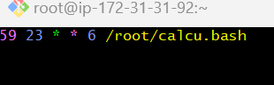

1. After every reboot

